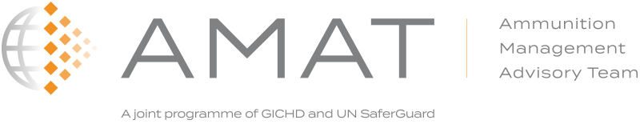

**1st Quarterly Report:** *January – March 2019*

**Introduction**

The Ammunition Management Advisory Team (AMAT) was jointly established in January 2019 by the Geneva International Centre for Humanitarian Demining (GICHD) and the United Nations Office for Disarmament Affairs (UNODA). It will enhance State and regional action on safe and secure management of ammunition with a view to reducing the risk of unintended explosions and diversion to the illicit market. This will be achieved by:

* *supporting States with technical advice in accordance with International Ammunition Technical Guidelines;*
* *transferring knowledge;*
* *facilitating of effective and sustainable international cooperation and assistance*.

This is the first quarterly report of AMAT’s activities since its establishment.

*30 January 2019*

**Presenting AMAT at the OSCE Forum for Security Cooperation (FSC) - Vienna**

GICHD’s director and the Head of AMAT participated in the OSCE Forum for Security Cooperation (FSC) seminar "Security Dialogue on Global Developments in the Area of Stockpiles of Conventional Ammunition", convened under the Swiss 4-month Chairmanship.

GICHD’s director presented his vision, objectives and priorities in relation to global and multilateral processes for managing ammunition stockpiles. He introduced AMAT, elaborating on how it can contribute to regional processes, including those of the OSCE.

*16-22 February 2019*

**Visiting Golden West Humanitarian Foundation** **– Cambodia**

AMAT’s Technical Advisors were invited by Golden West (GW) to visit their operation in Cambodia. GW are carrying out capacity building in IATG based ammunition management.

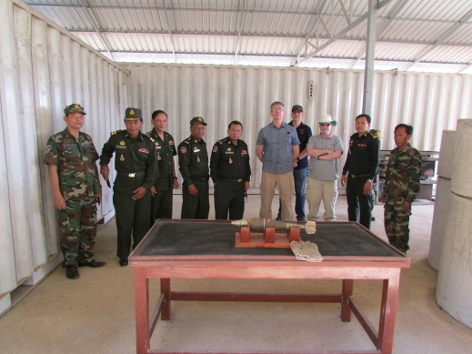

The programme is a good example of how to improve ammunition management, build capacity, convert unserviceable or surplus ammunition stocks into usable high explosive charges and produce good facilities. GW have developed a Virtual Reality ammunition recognition tool and are now developing a Virtual Reality training suite.

*6 March 2019*

**AMAT’s 1st Advisory Council Meeting – Geneva**

The first AMAT Advisory Council (AC) meeting was held in Geneva. The meeting was co-chaired by GICHD’s director and the Chief of Conventional Arms Branch of the UNODA. 20 representatives from donor and beneficiary States, international and regional organisations, and partners active in ammunition management took part.

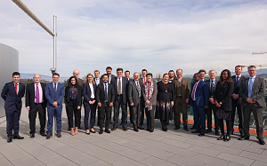The AC is a consultative organ to advise AMAT on its work and priorities. This meeting introduced AMAT and discussed the AC’s initial composition and functioning. Feedback on AMAT's draft 4-year strategy, work plan and envisaged modus operandi was given. (Please see meeting report in annex for more details)

**UN Saf*er*Guard Programme**

AMAT is planning to hold two validation exercises in 2019: one English, to be held in Austria in August, and one French, planned for October. Candidates for the English exercise have been selected to complete the online test to gauge their IATG knowledge.

The team will visit Senegal in May to meet with the national and international authorities to explore opportunities for collaboration with a view to carrying out the French validation exercise there.

AMAT’s technical advisors are working on improving the e-learning component of the validation process after feedback from the previous exercise.

**OTHER**

**HR:** In Q1, AMAT was composed of 4 staff members: Head, 2 Technical Advisors and 1 Programme Officer. Recruitment of 2 Programme Managers will be finalised in June 2019. A Junior Programme Officer should be recruited later this year.

**Communications:** AMAT’s website, amat.org, is now available and will be gradually enhanced throughout the year.

**Publications:** 3 new guides for the implementation of IATG were published under the UN SaferGuard Programme:

* [Critical Path Guide to the IATG](https://www.gichd.org/resources/publications/detail/publication/critical-path-guide-to-the-international-ammunition-technical-guidelines/)
* [A Guide to Developing National Standards for Ammunition Management](https://www.gichd.org/NationalStandards-AM)
* [Utilising the IATG in Conflict-Affected and Low-Capacity Environments](http://www.gichd.org/UtilisingIATGs) (UNIDIR)

They can currently be found on GICHD’s website, but will be on the AMAT website in due course.

**Finances:** The AMAT Trust Fund was established in early 2019 with the creation of 3 separate bank accounts in CHF, EUR and USD.

|  |
| --- |
| Total expenditures (estimate by 31.03.2019) = **CHF 250’000** |

For any questions or inquiries, please contact Nadim Amer, AMAT Programme Officer ([n.amer@gichd.org](mailto:n.amer@gichd.org)).